Sharon Kim

5/17/18

Mohamed Allali

CS 615—Digital Image Processing Project

**Image Restoration and Image Quality Measurement**

The goal for my project was to use image restoration techniques to restore old family photos. I also wanted to measure whether image quality increased after restoration, so metrics were developed to quantify image quality. The three image restoration techniques that I used were deblurring, contrast stretching, and color cast removal.

**Deblurring**

A research study was conducted by Kanjar De et al. in 2013 to measure image sharpness in the frequency domain, and in this study the researchers observed that when the blur of an image increases, the number of high frequency components in the image decreases. This means, a sharper, good quality image has a higher number of high frequency components compared to a blurred image, which has a lower number of high frequency components. This can also be confirmed by an image’s fourier transform.

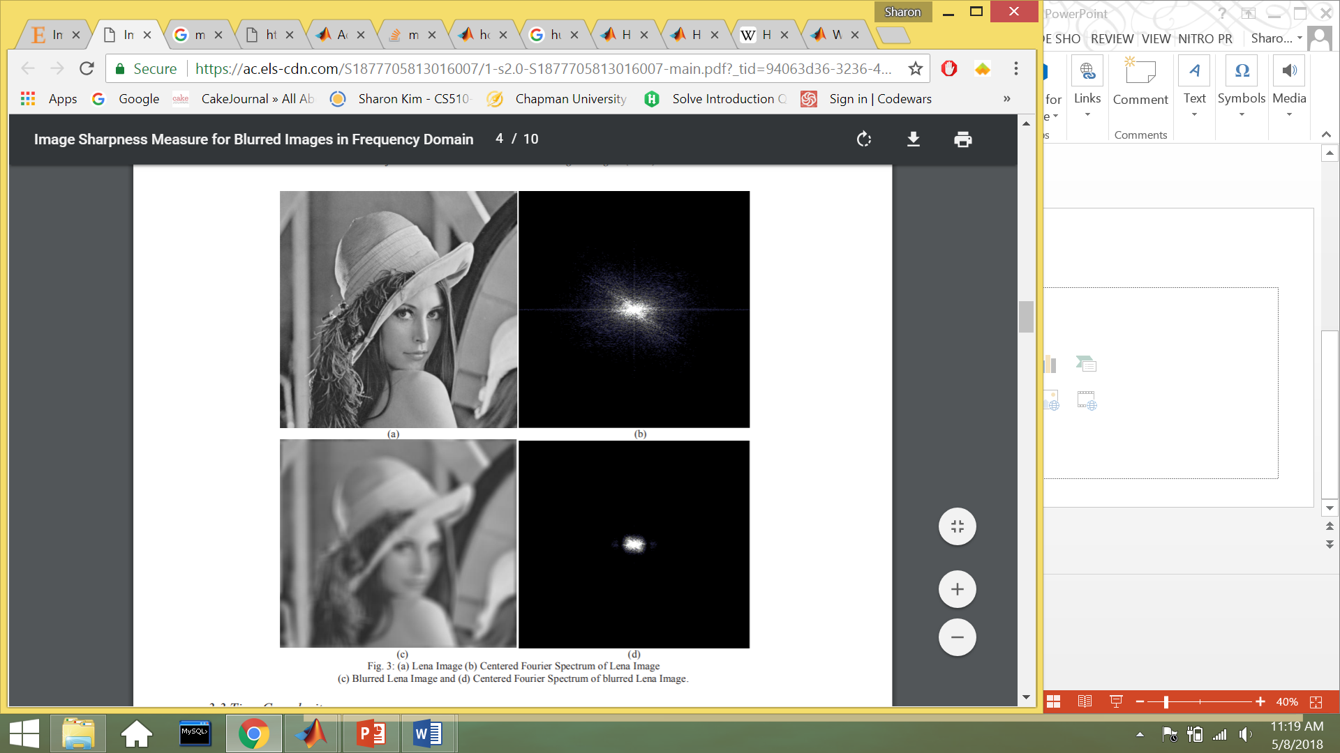

Because the researchers saw a correlation between higher frequency components with a sharper photo, they created an algorithm to calculate image quality.

**Algorithm**

* Input: Image I of size m x n.
* Step 1: Compute F which is the Fourier Transform representation of image I.
* Step 2: Find Fc which is obtained by shifting the origin of F to center.
* Step 3: Calculate AF = abs(Fc) where AF is the absolute value of the centered Fourier transform of image I.
* Step 4: Calculate M = max(AF) where M is the maximum value of the frequency component in F.
* Step 5: Calculate TH = the total number of pixels in F whose pixel values > threshold, where threshold = M/1000.
* Step 6: Calculate Image Quality Measure FM = TH / m x n.
* Output: Image Quality Measure (FM) where FM stands for Frequency Domain Image Blur Measure

The output FM provides a ratio to the number of pixels in the photo that are higher than the threshold value M/1000 with the number of pixels in the entire photo. When applying this algorithm to the image of the girl above, the TH score for the regular image is calculated to be 4780, and the TH score for the blurred image is calculated to be 1176. The FM score for the regular image is 0.0182, and the FM score for the blurred image is 0.0045. The closer the image quality metric is to 1, the less blurry the image is.

I applied the Image Quality Measure (FM) algorithm with my own research by programming the algorithm in matlab and running it on a blurred image and on a clear image. The blurry image that I used was an old elementary school citizenship awards ceremony.

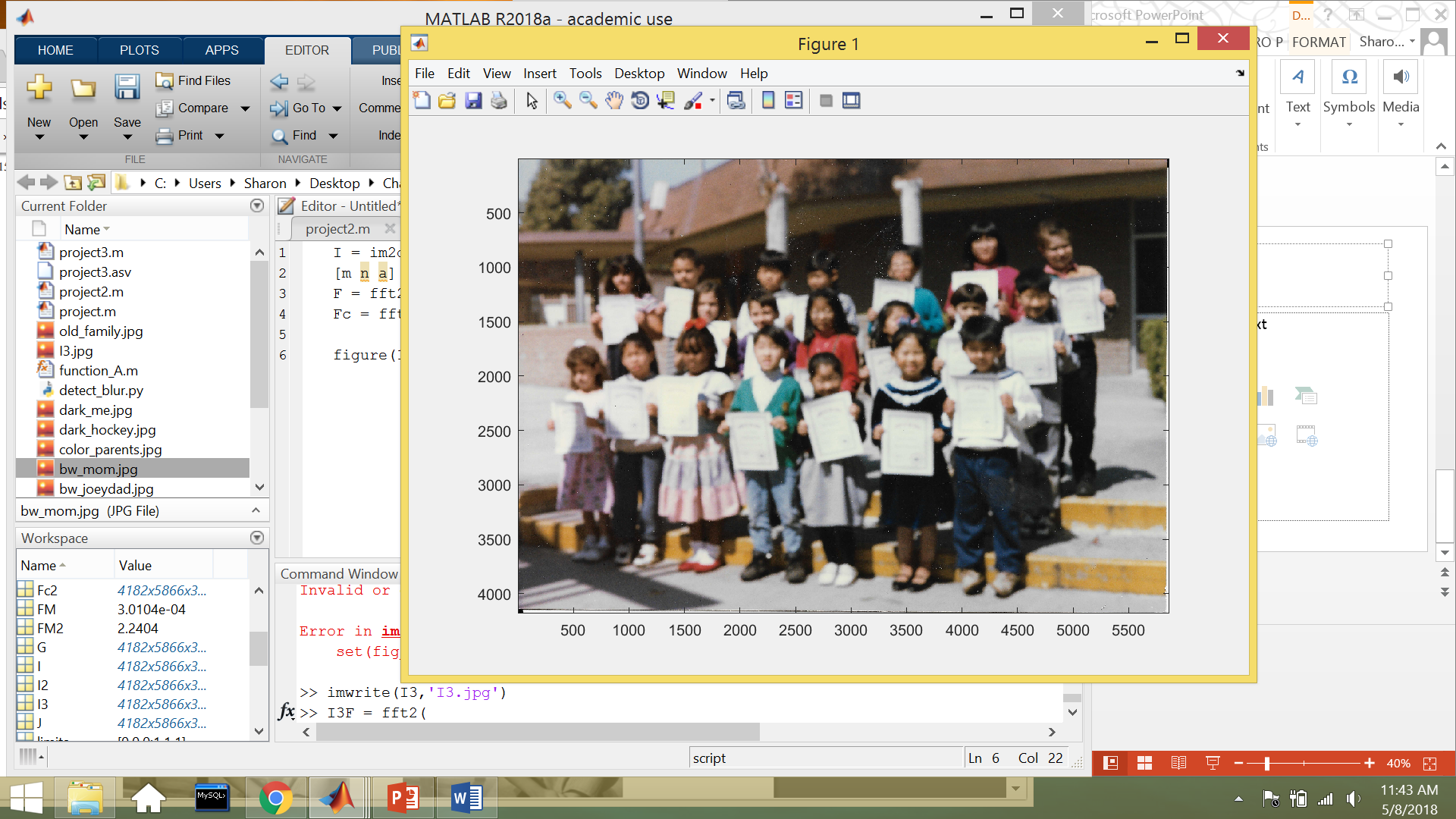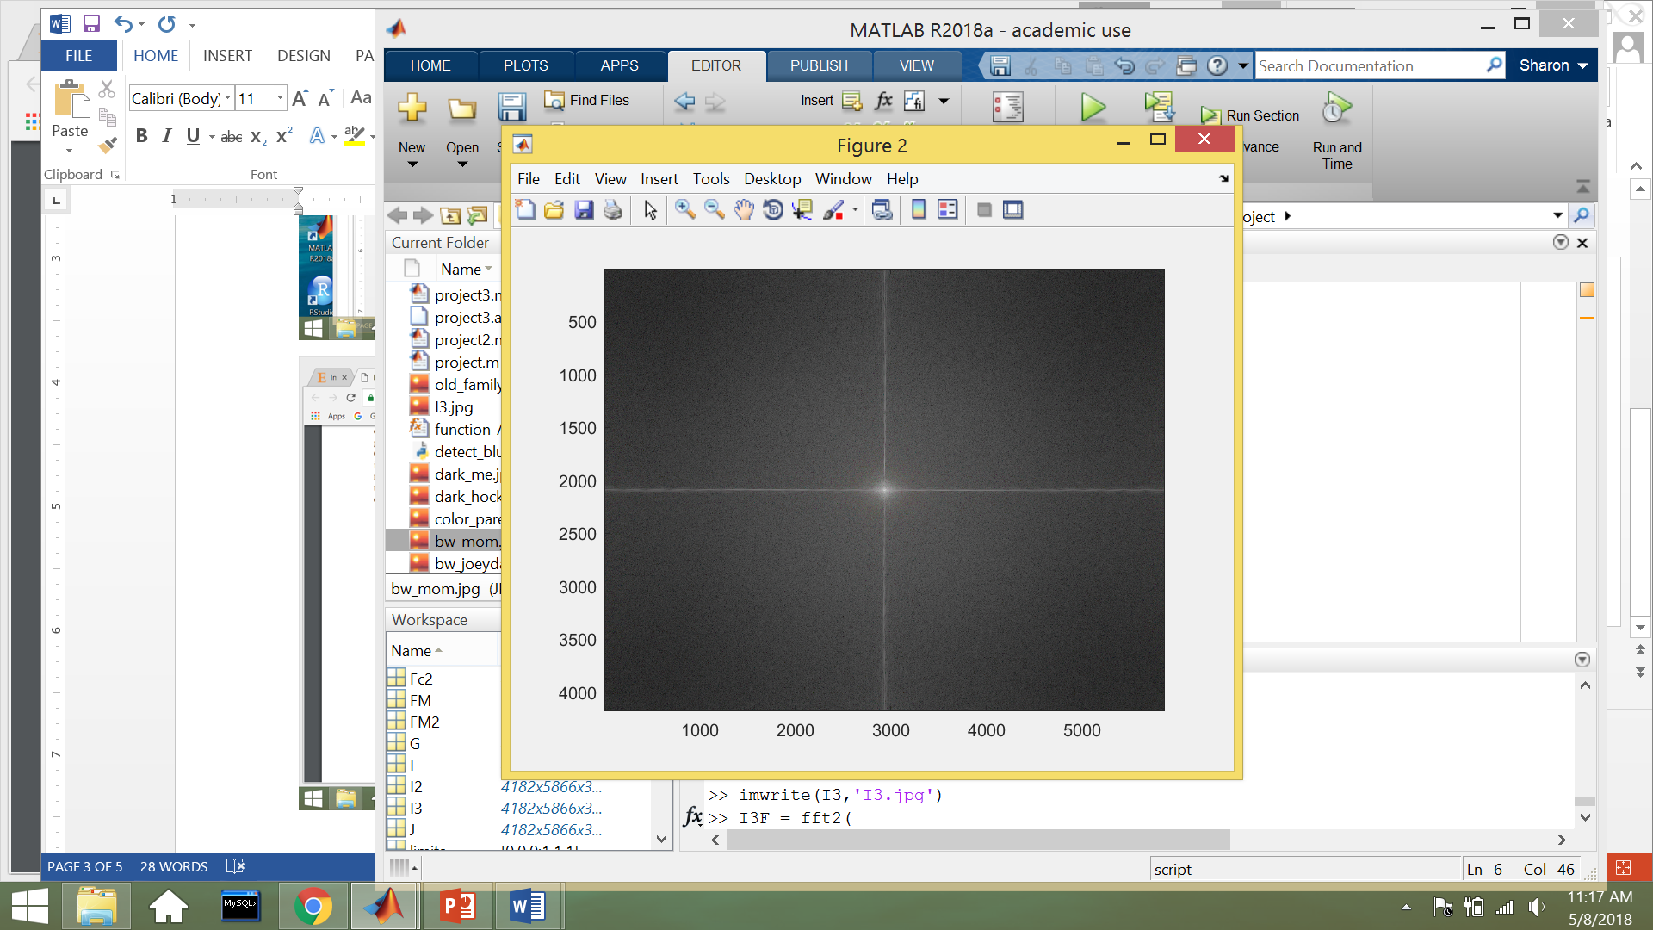

For this blurry image, I calculated that the maximum frequency component of this picture was M = 1.145e07, and that 7385 pixels (TH) had frequency components that were greater than M/1000. The image score (FM) for the blurry image was calculated to be 1.0035e-4. The Fourier transform of this image also shows that the image does not have too many high frequency values throughout the image.

I wanted to use methods that were discussed throughout the course, so I used the laplacian sharpening filter to deblur the image. Then, a median filter was used to remove salt and pepper from the RGB channels, and a Gaussian filter was used to soften the image.

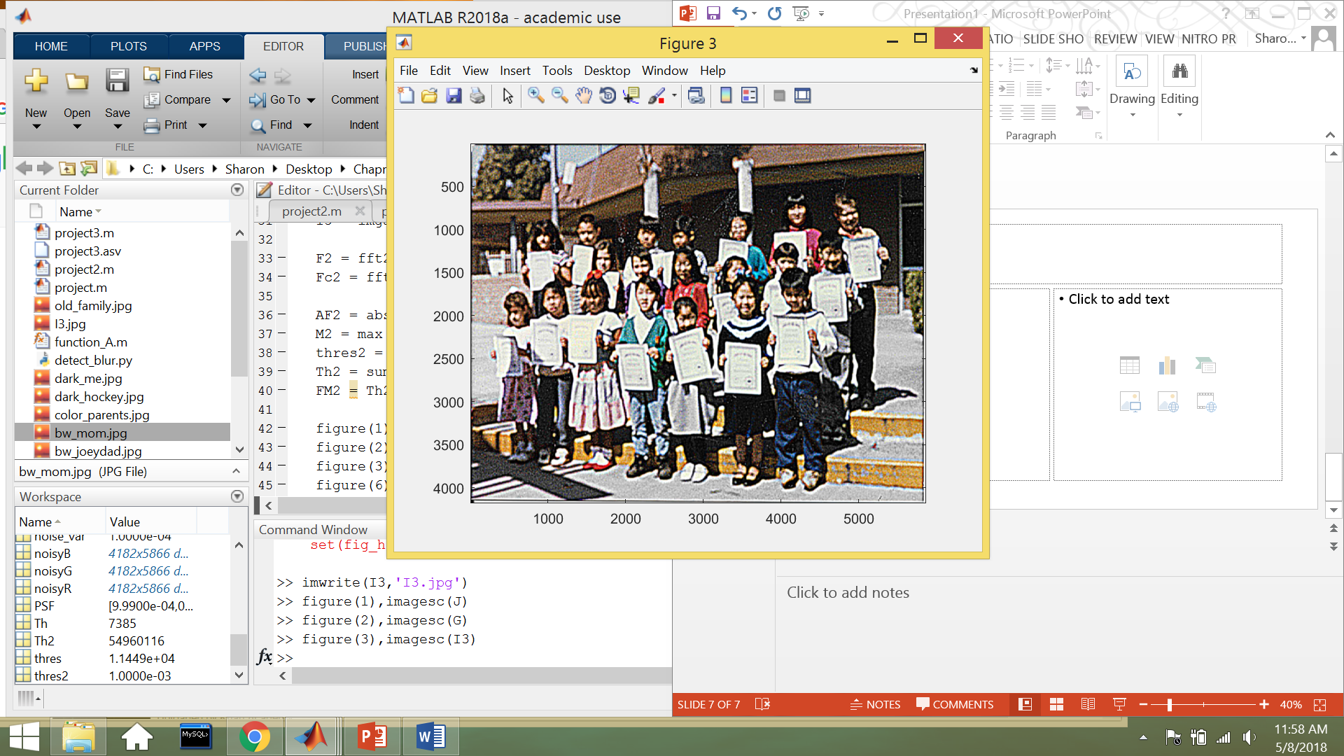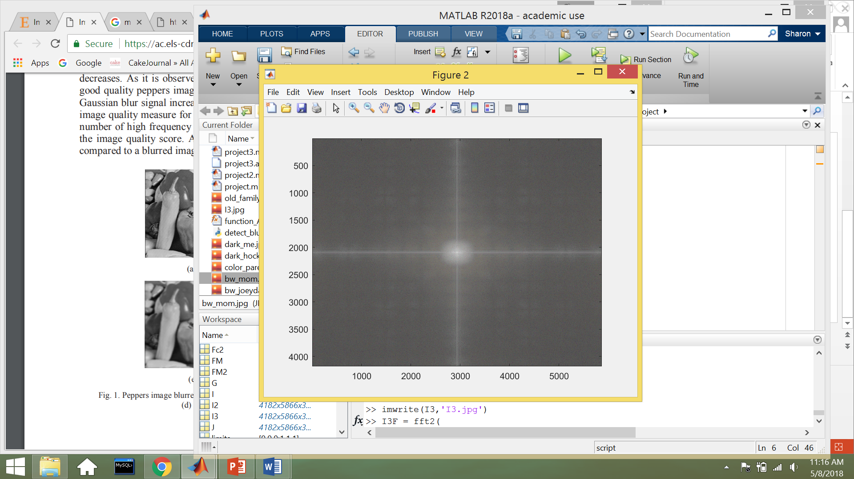

After restoring the blurry image to a sharper one, I used the Image Quality Measure (FM) algorithm to calculate the score which was 0.52. The algorithm definitely does measure image quality in terms of blurriness well. The image quality score improved from 0.0001 to 0.52. When comparing the Fourier’s of the two images, we can see that the deblurred image contains more high frequency components throughout the image.

**Contrast Stretching**

The next image enhancement process that I used was contrast stretching for color images. Contrast stretching normalizes the intensity values of the Red (R), Green (G), Blue (B) channels so that the full range of pixel values can be displayed in the image. It helps to restore a “washed out” image to have more color. The contrast measure that I used was the Root Mean Square (RMS) contrast. It is defined by the following function:

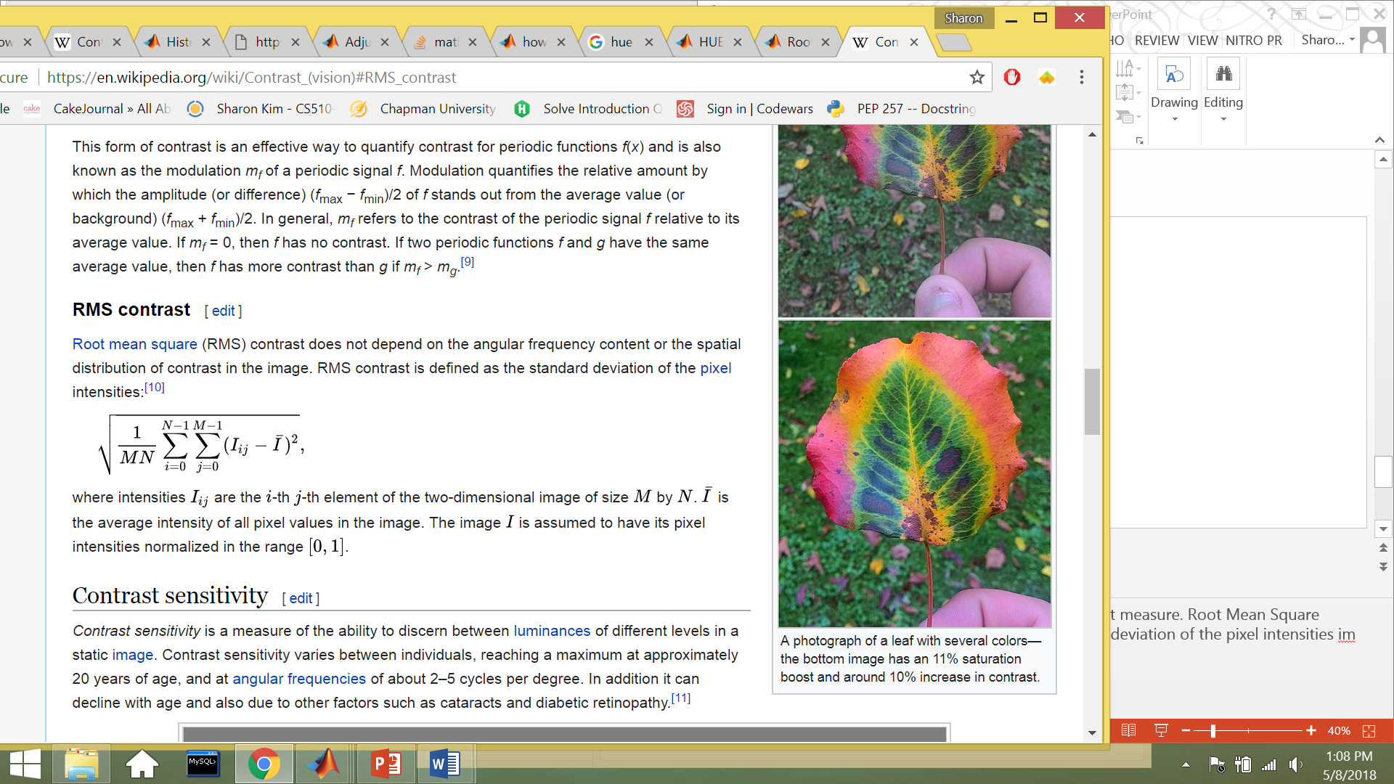

The RMS is defined as the standard deviation of the pixel intensities in the image, which basically means that the RMS measures the spread of the pixel values within the image. So, when the RMS is lower, the pixel values are spread out more evenly, which correlates well with the goal of contrast stretching.

The image I chose to enhance was an old wedding photo of my parents performing a traditional tea ceremony to honor their parents.

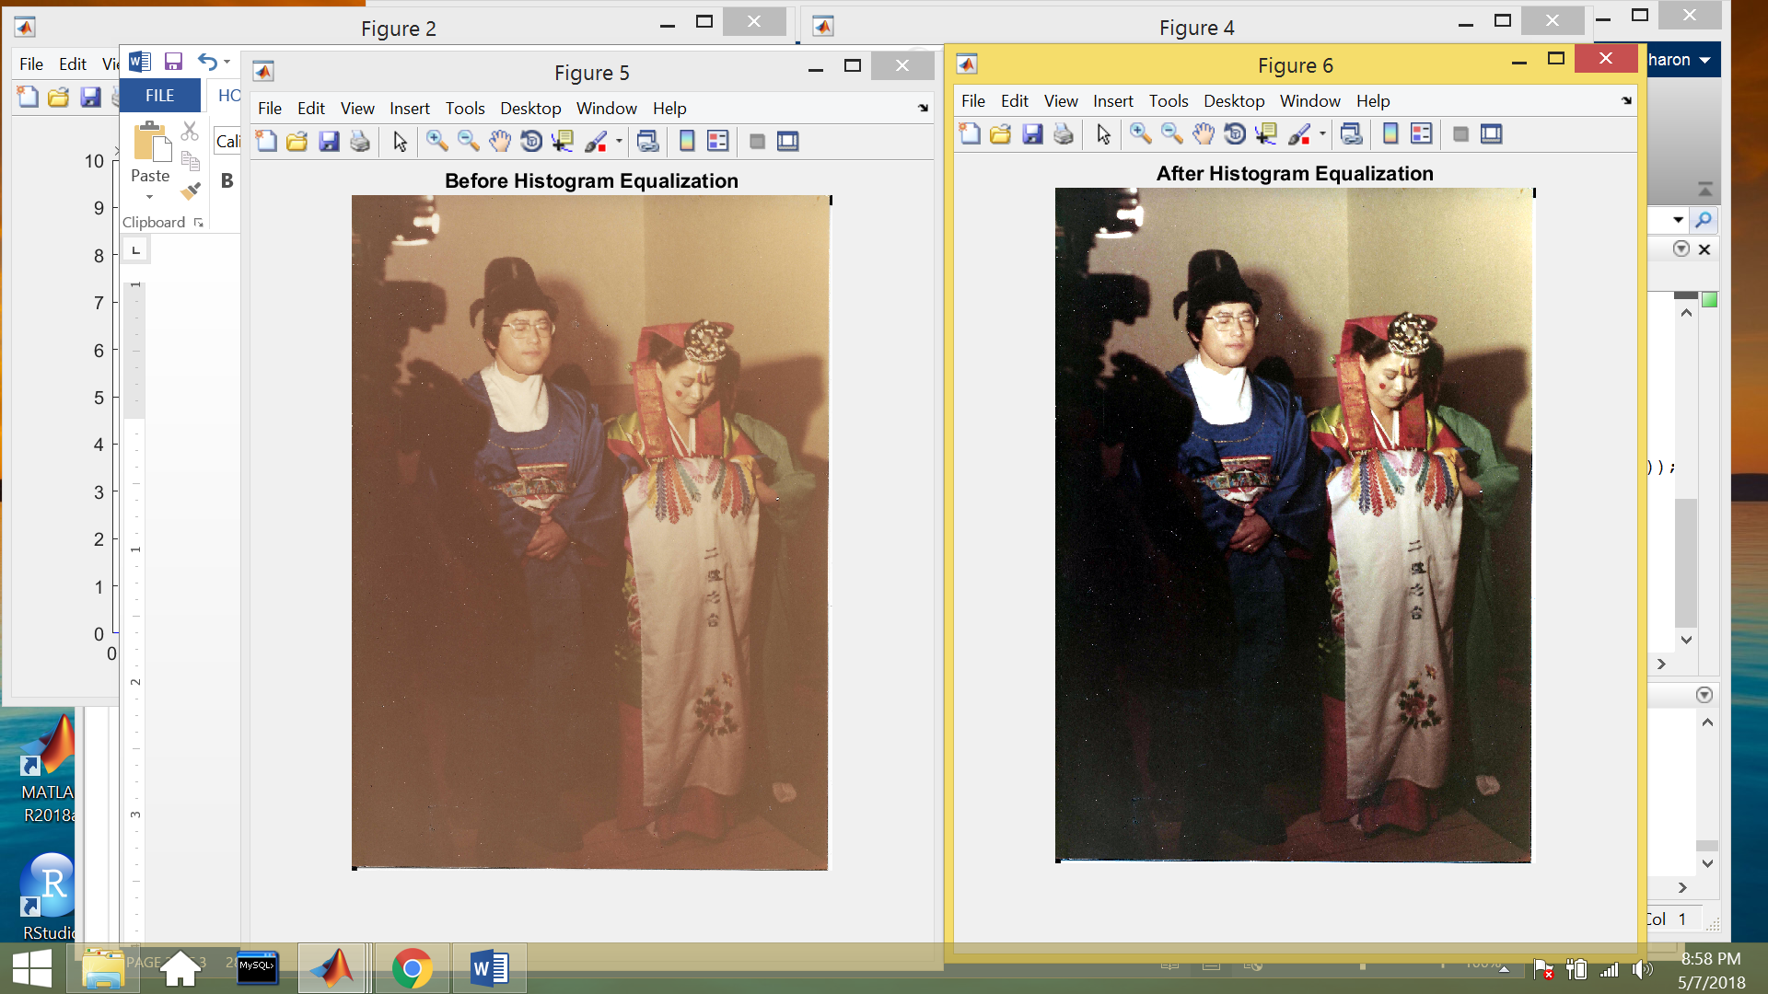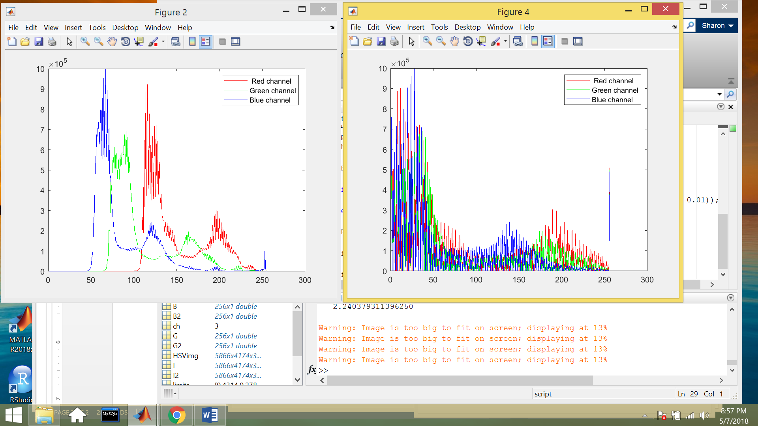

Visually, the photo looks a bit washed out. After plotting the R, G, B histogram, the channels do not fill the entire intensity range, and the RMS was calculated to equal 15.97. To improve the photo, I conducted contrast stretching on each R, G, B channel as well as contrast stretching on the Saturation (S) and Value (V) channels. As a result, the image was restored with more color, and the R, G, B histogram shows that the colors are spread more evenly throughout the entire intensity range. The RMS contrast metric was also calculated to be 0.39 for the restored photo. The RMS contrast metric is another great image quality measure that can be used to show improvement after image enhancement occurs.

 

**Color Cast Removal**

The next image enhancement process that I researched was color cast removal. Color casting is when a tint of a particular color is cast on the entire image. The two variables that define color cast for a picture are hue and chroma/saturation, where hue is the color of the image or pixel, and chroma is the intensity of the hue. The metric that I used to measure color cast was to measure the hue and chroma of the image. If the mean chroma of the image was over 50%, the image was likely to have a color cast on it. Histogram matching of a grayscale image can be used to remove color cast.

The image that I restored was an old family photo that appears to have a bluish green color cast.

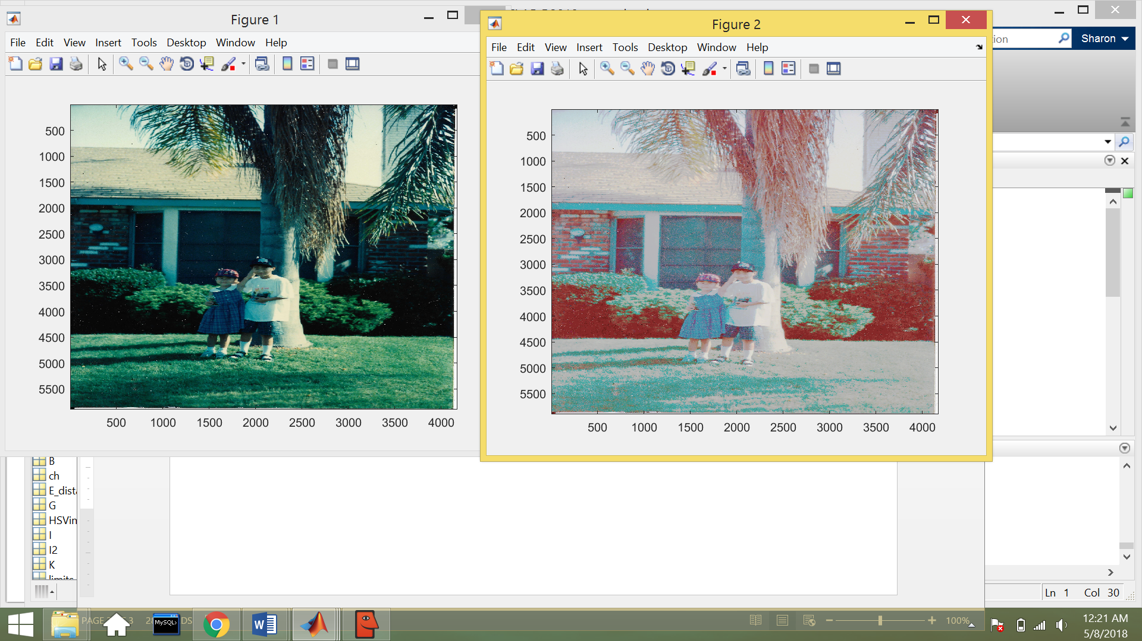 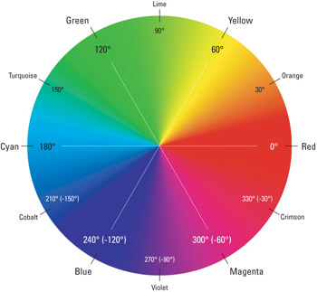

I converted the RGB channel to a HSV channel and found the average value of all of the hue angles in each pixel to get a hue angle of 145 degrees which means that the average hue of the picture is turquoise/green based on the 360o color wheel. I also found the average value of the chroma in each pixel to get an intensity of 52%. Through histogram matching, I wanted to reduce the chroma intensity to less than 50%.

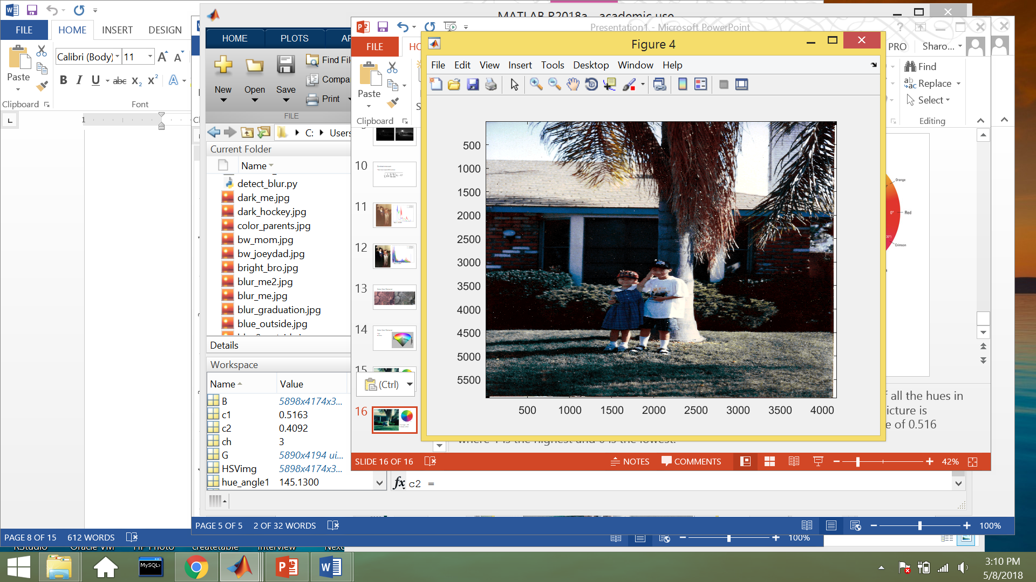

I implemented histogram matching the grayscale image, used a median filter to remove noise, and performed histogram equalization in the S and V channel to remove color cast and improve image quality. After restoring the image, I measured the average hue angle, which changed to 96 degrees. This hue angle falls under the lime yellow color wheel. The average chroma was also measured to be 41%. The reduction of the chroma intensity is a useful measure in determining color cast removal.

**More Examples**

More images were tested with these measures to produce the following results:

1. Deblurring
   1. Original Image
      1. FM = 1.11e-4
   2. Restored Image
      1. FM = 0.51

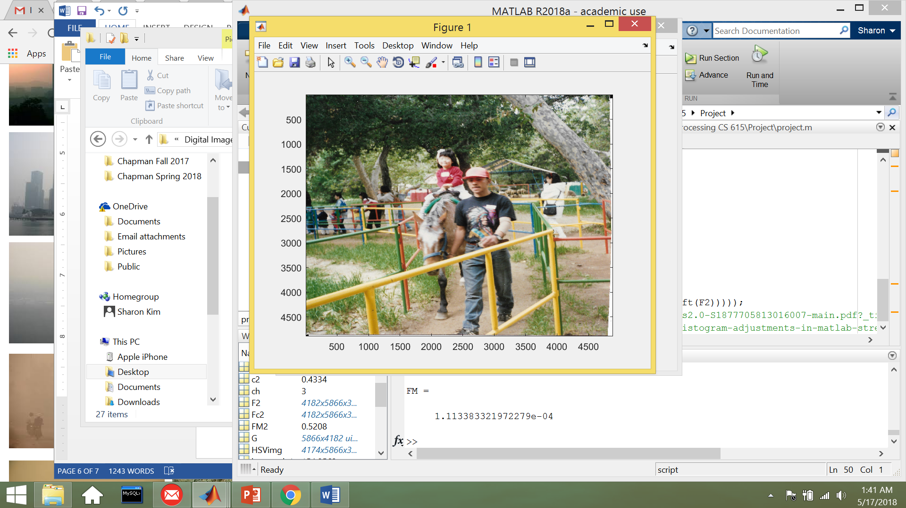 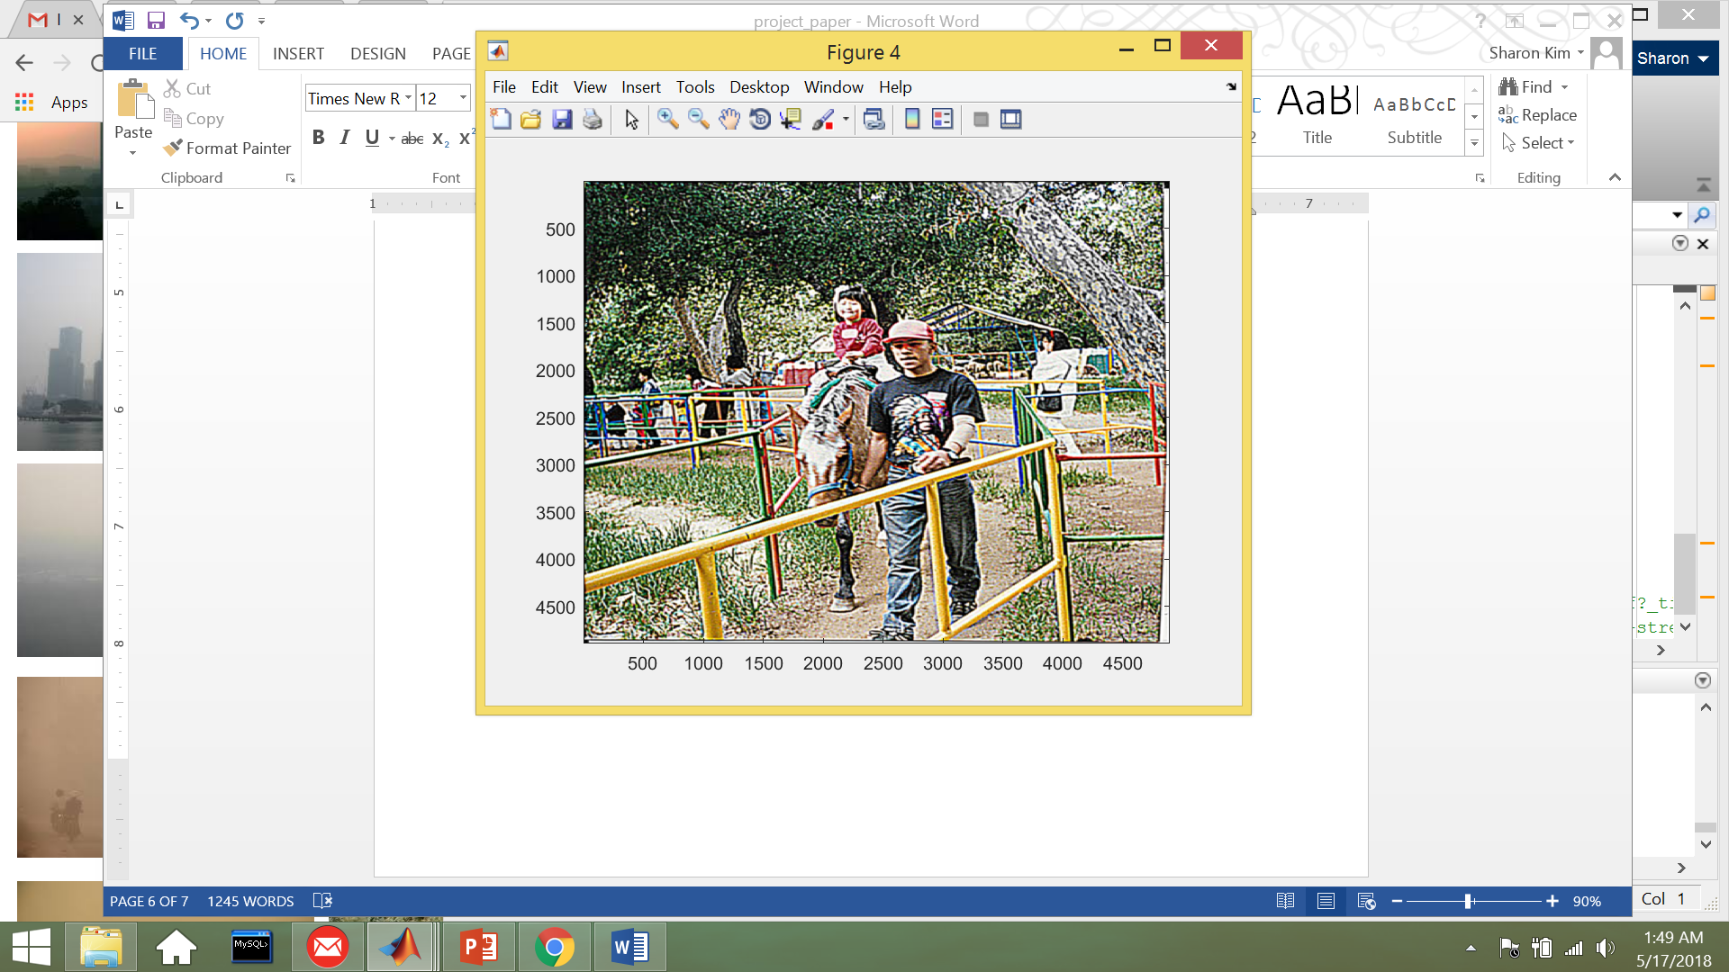

1. Color Contrasting
   1. Original Image
      1. RMS = 15.97
   2. Restored Image
      1. RMS = 0.72

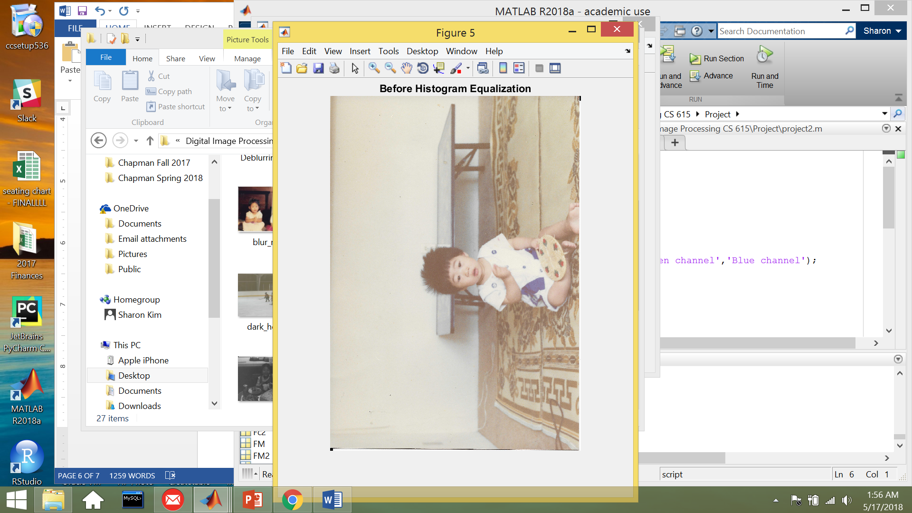 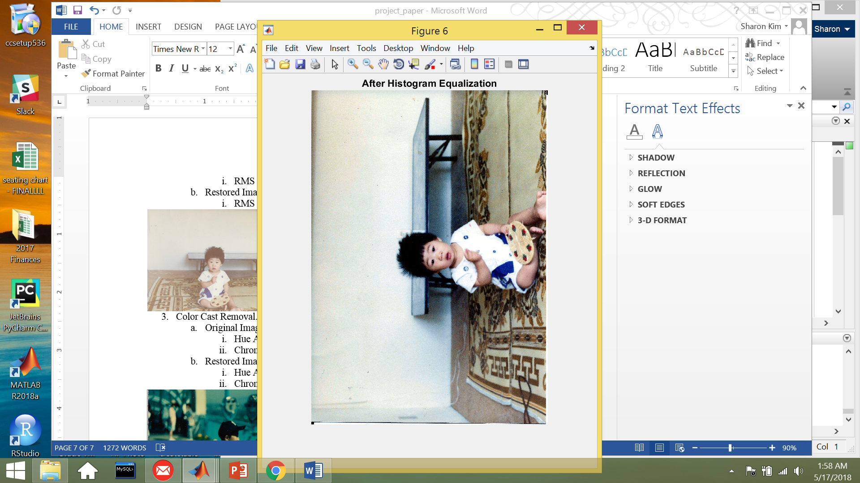

1. Color Cast Removal.
   1. Original Image
      1. Hue Angle: 155 degrees – Turquoise Blue
      2. Chroma: 66%
   2. Restored Image
      1. Hue Angle: 113 degrees – Green
      2. Chroma: 43%

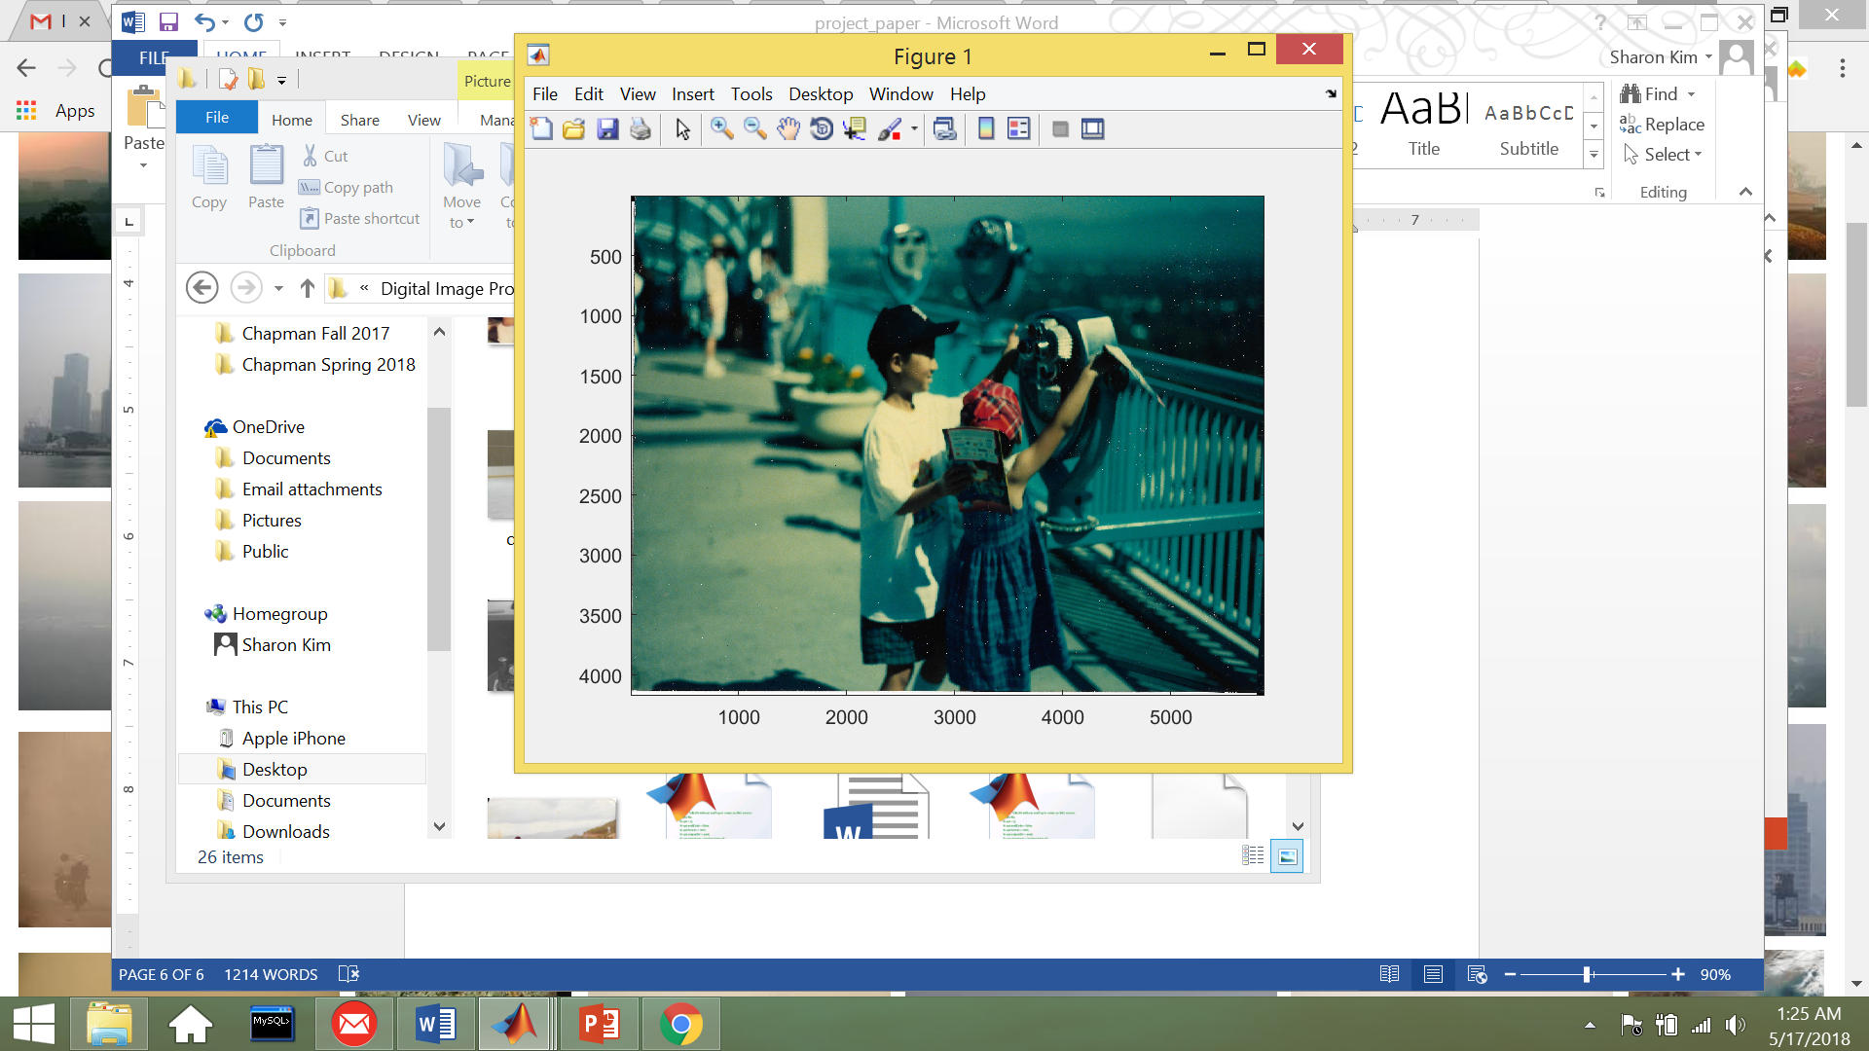 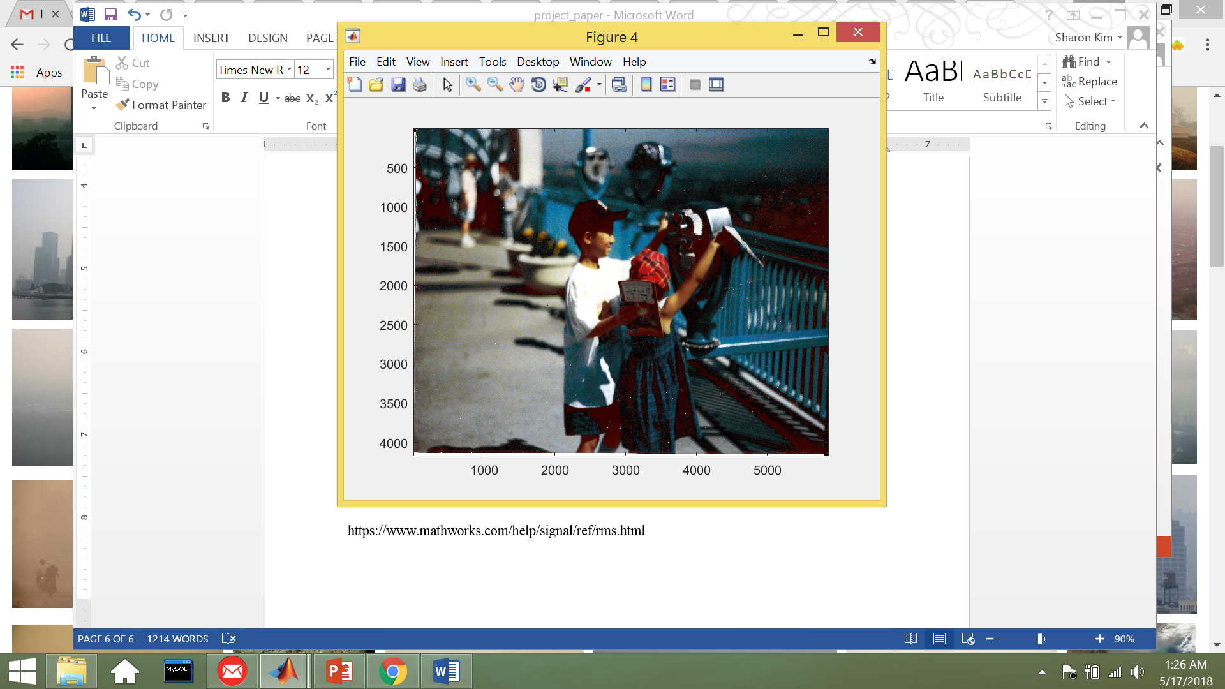

These examples confirmed that the metrics were useful tools to measure improvement in image quality. Some further research I would want to do is measuring all three metrics for 50 to 100 images that are blurry, need color contrast stretching, or require color cast removal. I would want to store those measurements into a table and use it in the application methods.

**Application**

After investigating image quality metrics to measure image restoration, it would be interesting to apply these metrics to automate image restoration processes. These metrics could be used as indicators to perform specific image restoration tasks on an image. Another way to apply this project is by using these metrics to build better image classification models that could classify the type of image restoration process that an image should undergo in order to increase image quality.

**References**

De, K. (2013). Image Sharpness Measure for Blurred Images in Frequency Domain. Science Direct,64, 149-158. Retrieved May 17, 2018, from <https://www.sciencedirect.com/science/article/pii/S1877705813016007>.

Mathworks. (n.d.). Retrieved May 17, 2018, from https://www.mathworks.com/help/signal/ref/rms.html

Mathworks. (n.d.). Retrieved May 17, 2018, from https://www.mathworks.com/help/images/convert-from-hsv-to-rgb-color-space.html